**Reference No:** C06…..

**Damage Report Date:** .12/12/12...

**Incidents must be reported immediately.**

Damage found in Container must not to be touched until pictures have been taken to effectively demonstrate to stake holders how damage could have arised?

In Container Container No:

In Warehouse How was it damaged? Rubbed against other object

Product…YST-SW216–Serial No. (21)034172WY……………….. Qty………1 box………

*Insert* Picture:

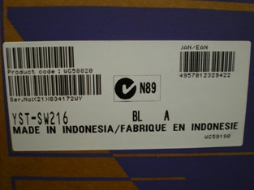

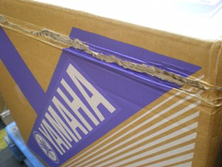

Reported by…YMA…………………………………………………………………….